February 14, 2003

James H. Pielert, P.E.
Manager, AASHTO Materials Reference Laboratory
100 Bureau Drive, Stop 8619
Building 202, Room 211
Gaithersburg, MD 20899-8619

Subject: Response to On-Site Assessment of Materials Testing Laboratory

Dear Mr. Pielert:

Enclosed is a summary of responses to the deficiencies found during the on-site assessment (No. 1303D) of the Civil Engineering Materials Laboratory at the University of Arkansas on October 16, 2002. In cases where the deficiencies involved documentation, the appropriate sections of the Quality Manual have been included. Details of response to each deficiency are listed on the enclosed summary.

I believe that all deficiencies have been answered properly. If you have any questions, please contact me as soon as possible.

Sincerely,

Stacy G. Williams, Ph.D., P.E.
Civil Engineering Materials Laboratory
Department of Civil Engineering
University of Arkansas

Enclosures

SUMMARY OF RESPONSES TO DEFICIENCIES

GENERAL APPARATUS:

Footnote (a): Sample Reducing Apparatus – “The width of the feeder pan presented for use with the Soiltest-make sample splitter was not equal to or slightly less than the total chute width of the splitter.

Response: This deficiency was resolved during the assessment. The feeder pan was replaced.

Footnote (b): General Purpose Balances – “The two Denver Instruments-make balances presented (Serial Nos. 234502 and 234503 did not conform to the sensitivity indicated in Table 2 0.1g for a class G2 balance). When tested at loads of 1, 0.5, 0.2, and 0.1 g, the balances indicated 0 g.

Response: These scales are not used for measuring weights of less than 10 grams. The scales have been labeled to indicate this requirement, and the equipment descriptions have been altered to indicate this requirement as well.

HOT MIX ASPHALT:

Footnote (a): T209-99 – “The equipment presented did not include a residual pressure manometer, or a vacuum gauge traceable to NIST (ASTM: calibrated absolute pressure gauge), connected at the end of the vacuum line using an appropriate tube and either a “T” connector on top of the vacuum vessel or by using a separate opening in the top of the vessel. Consequently, it was not known whether the residual pressure inside the vacuum container was maintained at 3.7 ± 0.3 kPa (27.75 ± 2.25 mm Hg) during the test.”

“The equipment presented did not include a manometer or vacuum gauge connected directly to the vacuum source or in the vacuum line close to the source.”

Response: A new digital manometer, traceable to NIST, has been purchased and installed. Copies from the Quality Manual of paperwork regarding this item are enclosed. Also, the tubing and gauge have been repositioned such that there is a gauge at the vacuum source. A photo has been provided of this equipment for review.

Footnote (b): T312-01 – “The gyratory compactor presented did not shut off when the desired number of gyrations was reached. The compactor performed five additional gyrations, with the angle removed, to level the top of the specimen.”

Response: The number of dwell cycles on the compacted has been set to zero. However, according to AASHTO T-312, Note 6, “No additional gyrations with the angle removed are required unless specifically called for in another standard referencing T 312 . . .” According to this statement, there does not appear to be a restriction on the use of dwell cycles.

SOIL:

Footnote (a): T89-02 – “During liquid limit testing, the unused soil in the storage dish was not covered to retain the moisture in the sample. The unused soil was left uncovered in the storage dish.”

Response: The technician has reviewed the specification and now correctly performs the procedure, covering the unused bowl of soil with plastic. Although a similar deficiency was noted in the previous assessment, a different technician performed the test during this assessment.

QUALITY SYSTEM CRITERIA:

Footnote (a): Proficiency Sample Testing – “Records describing steps taken to determine the cause of poor results and corrective actions taken for proficiency sample testing were not presented for AMRL Hot Mix Asphalt Proficiency Samples 13 and 14 (Sections 5.10 and 6.6.1).

Response: A response was prepared describing corrective actions taken for HMA samples 13 and 14. This report was not complete at the time of the assessment, but was submitted shortly thereafter – within the 60 day time frame required by AMRL procedures. A copy of this report is enclosed.

Footnote (b): Technician Training and Evaluation Records – “The technician training records presented for Curtis Osier indicated that evaluations had not been performed for AASHTO Test Methods T11, T87, T248, and T310.”

Response: Although training had taken place, records were incomplete. This training took place in conjunction with training courses taught here at the University. A copy of the updated training records are enclosed with this report.

Footnote (b) cont.: Technician Training and Evaluation Records – “The technician training records presented for Kevin Hall indicated that evaluations had not been performed for AASHTO Test Methods T287 and T308.”

Response: Although training had taken place, records were incomplete. This training took place in conjunction with training courses taught here at the University. A copy of the updated training records are enclosed with this report.

Footnote (b) cont.: Technician Training and Evaluation Records – “The latest two technician competency evaluation records presented for Stacy Williams indicated that the evaluations had not been completed within the 12-month interval specified in the laboratory’s quality manual (Section 5.9). The records indicated that evaluations for AASHTO Test Methods T84, T255, and T275 were last performed in October 2000, and an evaluation for AASHTO Test Method T100 was last performed in February 2001.”

Response: Although training had taken place, records were incomplete. This training took place in conjunction with training courses taught here at the University. A copy of the updated training records are enclosed with this report.

Footnote (b) cont.: The latest two technician competency evaluation records presented for Curtis Osier indicated that the evaluations had not been completed within the 12-month interval specified in the laboratory’s quality manual (Section 5.9). The records indicated that evaluations for AASHTO Test Method T265 was last performed in January 2001.”

Response: Although training had taken place, records were incomplete. This training took place in conjunction with training courses taught here at the University. A copy of the updated training records are enclosed with this report.

Hot Mix Asphalt: Footnote (a)

A NIST traceable digital manometer (shown below) has been purchased and installed with the vacuum system.

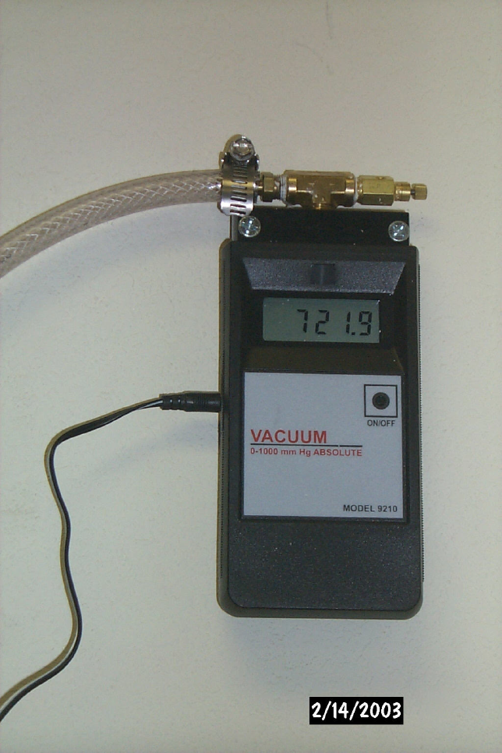

A vacuum gauge has been repositioned using a “T” connector at the vacuum pump (shown below).

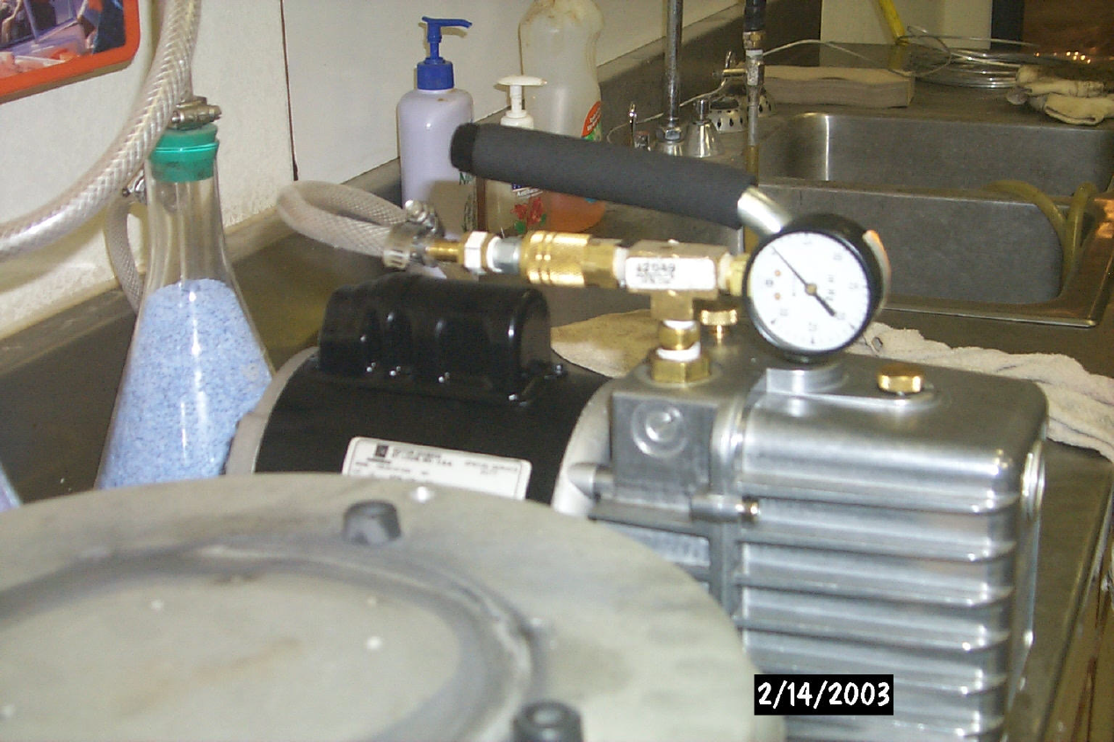

The overall setup for method T209 is shown in the following photo.

